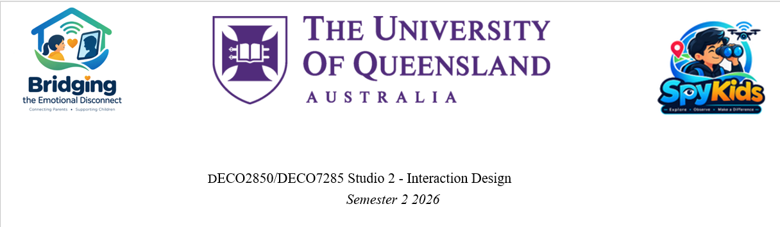

Master Design Refinement
Response to Milestone 1 Feedback
Market positioning, feature-by-feature critique, and a redefined project gap

Document No: SK-P1-004

This Document Does
Milestone 1 feedback from Chris and Sergy asked for four things before the team locks in scope for Milestone 2. This document works through all four, using only what the Master Research Synthesis and a fresh market scan actually support — not what would be convenient to claim.
Chris's ask | Where it's answered
1. What's out in the market, and how we differ | Section 2 — Competitive Landscape
2. Is "bridging emotional disconnect" already solved by other tech? | Section 3 — Insight-by-Insight Market Check
3. Simplify to the few features that target the real gap; exclude what's already used elsewhere; redefine the gap | Section 5 — Feature Critique, Section 6 — Redefined Gap, Section 7 — Simplified Scope
4. Further reading — Sengers, Reflective Design; ChatStat as a competitor | Section 4 — Reflective Design Lens; ChatStat covered in Section 2

2. Competitive Landscape
Methodology note: this is desk research — public product pages, press coverage and marketing copy — not hands-on testing or an app-store teardown. Where a verdict below says "genuinely novel" or "not found in any reviewed product," read that as "not found in public product descriptions," not as a verified absence in shipped code.
Eight products/platforms sit close enough to Baobei's territory to matter. None target our exact population (migrant-labour families, left-behind children, low-connectivity rural households) — but several already implement the exact interaction mechanics Baobei is builing or proposed.
Product | Category | What it actually does | Overlap with Baobei
Toymail Talkies | Voice-message plush toy (consumer, US) | Press a button, record a voice message, send via app to parent-approved contacts. Screen-free for the child. Toy makes a sound / lights up on receipt; press again to play. "Jumpie" add-on notifies parents when the toy is picked up. Multiple contacts (a "Trusted Circle") can message the same toy. | Near-exact match to our core loop: squeeze-to-record, squeeze-to-play, notification-on-receipt, no child-side screen, multi-party contact list.
TeddyMozart | Voice-message plush toy (consumer, China-adjacent market) | Same voicemail-to-plush mechanic as Toymail, reportedly marketed to Chinese-speaking families (carried over from earlier research — worth re-verifying independently before citing to the panel). | Same core loop, and closer to our actual market/language context than Toymail, pending that re-check.
Bond Touch | Wearable signal bracelet (partner-to-partner) | Tap your bracelet; the paired bracelet lights up and vibrates. No voice, no content — a pure ambient "thinking of you" signal. | Closest existing analogue to our heart-LED light-up feature, though built for romantic partners, not parent–child.
CloudPets | Connected plush toy (discontinued) | Same voice-message-to-plush concept as Toymail, but suffered a major data breach exposing children's voice recordings and account data. | Cautionary precedent only — the reason our recording/storage decisions need to be defensible, not a feature to emulate.
Moxie (Embodied Inc.) — now defunct | AI companion robot, was US $799 | Ran an on-device/cloud conversational AI that talked with the child directly, daily "missions" on empathy and emotion regulation, and a parent dashboard tracking social/emotional progress. Embodied Inc. shut down in Nov 2024 after a funding round collapsed; cloud servers went dark 30 Jan 2025, bricking every unit with no refunds (a volunteer project, OpenMoxie, later revived some units on local servers). | Solved a different problem (substituting for conversation, not relaying a real parent's voice), and its dashboard is exactly the tracking pattern Insight C argues against. Its collapse is now also a second cautionary tale, alongside CloudPets: a companion device that depends entirely on a company's cloud servers can die with the company. Baobei's local-first design (on-device cache, no subscription cloud AI) is a genuine resilience advantage worth stating, not a coincidence of budget.
ChatStat | AI child-safety monitoring app | Scans a child's public social media for cyberbullying, self-harm and risk signals; gives parents real-time alerts and a "personalised dashboard" with mood trends. No app or device needed on the child's side; explicitly framed as non-spying, public-data-only. | The clearest existing example of a mood-tracking parental dashboard for exactly the age group we're designing for — direct evidence for why our own mood widget is not a gap worth filling, just a smaller copy of an existing safety product.
WeChat-based parenting / UNICEF caregiver platforms | Informational support platforms (China) | Deliver parenting guidance, hotline access and check-in prompts to caregivers of left-behind children, over an app caregivers already use. | Addresses caregiver support directly, but has no embodied object for the child and doesn't touch the stigma or ambient-familiarity problem our interviews surfaced.
TalkingParents / OurFamilyWizard | Co-parenting communication apps (divorce/custody) | Logged, timestamped messaging between separated parents; TalkingParents' "Sentiment Scanner" flags emotional tone before a message is sent. | Different context (co-parent conflict, not distance), but the sentiment-scoring pattern is the same tracking/scoring instinct our mood widget and streaks reproduce — worth noting as a pattern to avoid, not adopt.
Bottom line: the plush-toy-plus-app voicemail mechanism is not new. Toymail alone has been shipping it since 2016, with the multi-contact list, notification-on-receipt, and no-screen-for-the-child properties we've been treating as evidence-backed design wins. If the Milestone 2 pitch leads with "we built a bear that lets you send voice messages," it will read to an assessor familiar with the space as a re-skin, not a contribution.
Worth stating plainly: two of the eight products reviewed (CloudPets, Moxie) no longer exist in a form families can rely on — one from a data breach, one from a funding collapse that bricked every unit overnight. Neither failure was about the core idea; both were about dependency (on a vendor's data practices, or on a vendor's cloud servers staying funded). Baobei's local-first hardware — recordings cached on-device, playback working without a live cloud connection — sidesteps the second failure mode by design, which is a genuine, engineering-backed point in the redefined gap below, not just a defensive footnote.

3. Is "Bridging Emotional Disconnect" Already Solved? — Insight by Insight
Going insight-by-insight against the landscape above, being honest rather than generous:
Insight / principle | Already solved elsewhere? | Verdict
1 — Asynchronous, personalised micro-interactions | Yes. This is Toymail's and TeddyMozart's entire premise. | Not novel
2 — Embodied ambient familiarity (plush, not a call) | Yes. Toymail, TeddyMozart and CloudPets are all built on exactly this premise. | Not novel
3 — Caregiver-light, zero-setup operation | Largely yes. In Toymail's model the caregiver never touches the app either — setup is done once by the connected adult. | Weak differentiator
4 — Playful, non-clinical, non-stigmatising object | Partially. Toymail/TeddyMozart are plush-first for the same anti-stigma reason, but for a general consumer market, not specifically for children who may feel marked out as a welfare case. | Context-specific, not mechanism-specific
A — Child-initiated, transparent recording only | Yes, already standard practice — Toymail is push-button-only with no remote activation. | Good practice, not a gap
B — Asymmetric reply-status visibility (child never sees "unanswered") | No. None of the reviewed products hide pending/unanswered state from the child — if anything Toymail's model is symmetric. | Genuinely novel
C — Evidence against mood-check-ins / interrogation | The opposite is common: Moxie (while it operated) and ChatStat both built/build parent-facing mood/progress dashboards as their headline feature. | Novel as a refusal
Two rows carry the actual argument for a contribution: B is a positive design move nothing else in the market does, and C is a deliberate, evidenced refusal to build the dashboard pattern that two direct competitors (Moxie, ChatStat) treat as their headline feature.

4. A Reflective Design Lens (Sengers et al., 2005)
Sengers, Boehner, David & Kaye's Reflective Design argues that most HCI design unconsciously reproduces cultural assumptions rather than examining them — and that a critical technical practice means deliberately surfacing those assumptions so they become a conscious choice, not a default.
Applied here: the mainstream smart-companion category we're sitting inside (Moxie's dashboard, ChatStat's mood trends, TalkingParents' sentiment scanner, our own cut mood widget/streaks) all share one unexamined assumption — that connection is demonstrated through data: a score, a streak, a trend line the parent can check. That assumption is what our own ethics table already pushed back on instinctively, before we had the language for it.
Read through Sengers, cutting the mood widget, coins, streak and hug-detection isn't just "unevidenced feature trimming" — it's a conscious rejection of the surveillance/quantification default the rest of the category has normalised, made for a population (stigma-sensitive, already-monitored-feeling children) where that default is actively harmful, not just unproven. That is the kind of "alternative possibility" reflective design asks designers to build toward, and it is a legitimate, citable design stance for Milestone 2 — a genuine contribution — even though the physical object and the voicemail mechanic underneath it are not new.

5. Feature-by-Feature Critique
One rule threads the two tables below, so the logic doesn't look inconsistent on a close read: market overlap by itself never disqualifies a feature — it only disqualifies the claim that a feature is novel. Send voice note, message status and squeeze-to-play all exist elsewhere too, and they're kept, because they're evidence-backed core loop, just not a novelty claim. Features are cut for an evidence gap, an ethics conflict, or physical infeasibility; market overlap is noted for the cut features only as an extra reason stacked on top of one of those three, never as the reason on its own.

5.1 Mobile app (Figma) features
Feature | Evidence trace | Exists in market already? | Verdict
Send voice note | Insight 1 | Yes — Toymail, TeddyMozart | Keep — core, not a novelty claim
Message / connection status | Insight 2 | Yes — Toymail's receipt notification | Keep — core, not a novelty claim
Light up the bear (heart LED) | Hardware / Insight 2 | Closest analogue: Bond Touch (different pairing context) | Keep — reasonable combination
Lullaby | Insight 2 (content variant of voice note, not a separate feature) | N/A — not marketed as new | Keep — fold into voice note
Play music | None documented | Yes — Toymail sells this as a paid add-on already | Cut / defer
Coins / day streak / check-in streak | None; surveillance risk on current design | Pattern matches ChatStat/Moxie dashboards and TalkingParents' sentiment scoring | Cut
"Word Chain" game | None; contradicts screen-free premise | Saturated category (Duolingo ABC, Khan Kids, etc.) | Cut
Mood widget ("Happy today") | Contradicted by Insight C; conflicts with own ethics table | Yes — this was Moxie's headline feature and remains ChatStat's, both at far greater sophistication than a static widget | Cut
Hug detection ("your child hugged the bear") | No sensor exists in the build | Partially — Toymail's "Jumpie" motion-pickup add-on | Cut
"Warm" | No heating element in the build — physically impossible this semester | N/A | Cut

5.2 Bear (hardware) features
Feature | Evidence trace | Exists in market already? | Verdict
Squeeze-to-play / squeeze-to-record | Insight 1 | Yes — same pattern as Toymail's button-press record/play | Keep — core, not a novelty claim
Ambient heart LED notification | Insight 2 | Closest analogue: Bond Touch | Keep — reasonable combination
Magnetic dock, zero setup | Insight 3 | Largely matched by Toymail's set-once model | Keep — but don't oversell as unique
Plush bear form, not a visible device | Insight 4 | Yes as an object category — but not for this population specifically | Keep — context makes it defensible
Child-initiated recording only (no remote activation) | Insight A — recommend formalising | Standard already in Toymail | Formalise as a stated commitment
Asymmetric reply-status visibility | Insight B — recommend formalising | Not found in any reviewed product | Formalise — build and demo this
Local-first, offline-tolerant sync (store-and-forward when connectivity drops) | Engineering response to the rural-connectivity constraint in Focus Area 3, not a single interview quote | Toymail/TeddyMozart assume stable home Wi-Fi; Moxie's cloud-only design is the cautionary counter-example | Elevate — now central to the redefined gap

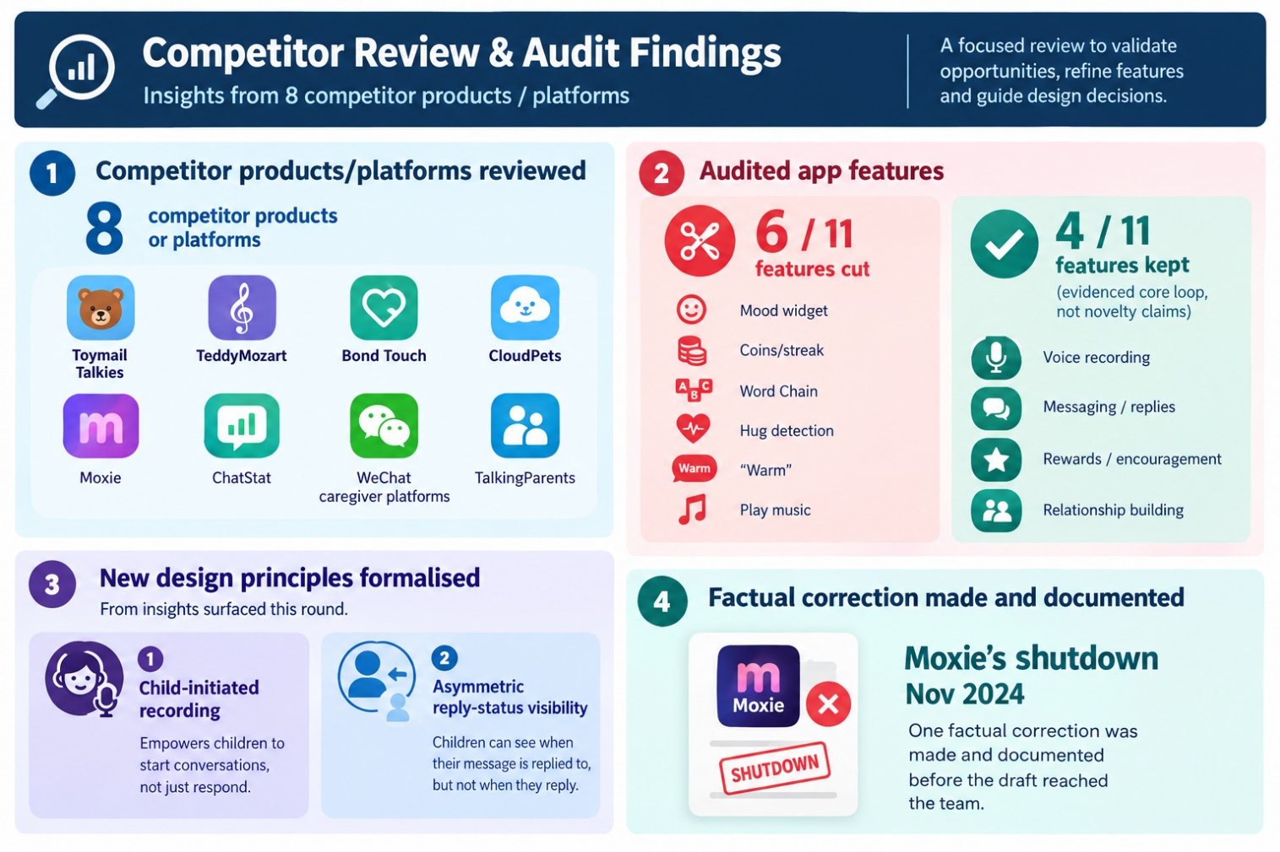

5.3 Deferred — "Digital Parental Platform" backlog
Avatar, camera-based greeting hub, and gamified-rewards ideas from the parallel synthesis matrix stay in the Future Platform Exploration backlog (existing team decision). Worth naming explicitly: this territory is where well-funded AI-companion products have tried to operate — and Moxie's own collapse (Embodied Inc. shut down Nov 2024, every unit bricked when its cloud servers went dark) is a warning, not just a resourcing gap: a cloud-dependent AI companion is a heavy, fragile bet even for a funded startup. That's a second reason to leave this backlog deferred — not because we couldn't resource it, but because the failure mode if we tried would be worse than the one we're avoiding.

5.4 Baobei Redefined Process Map
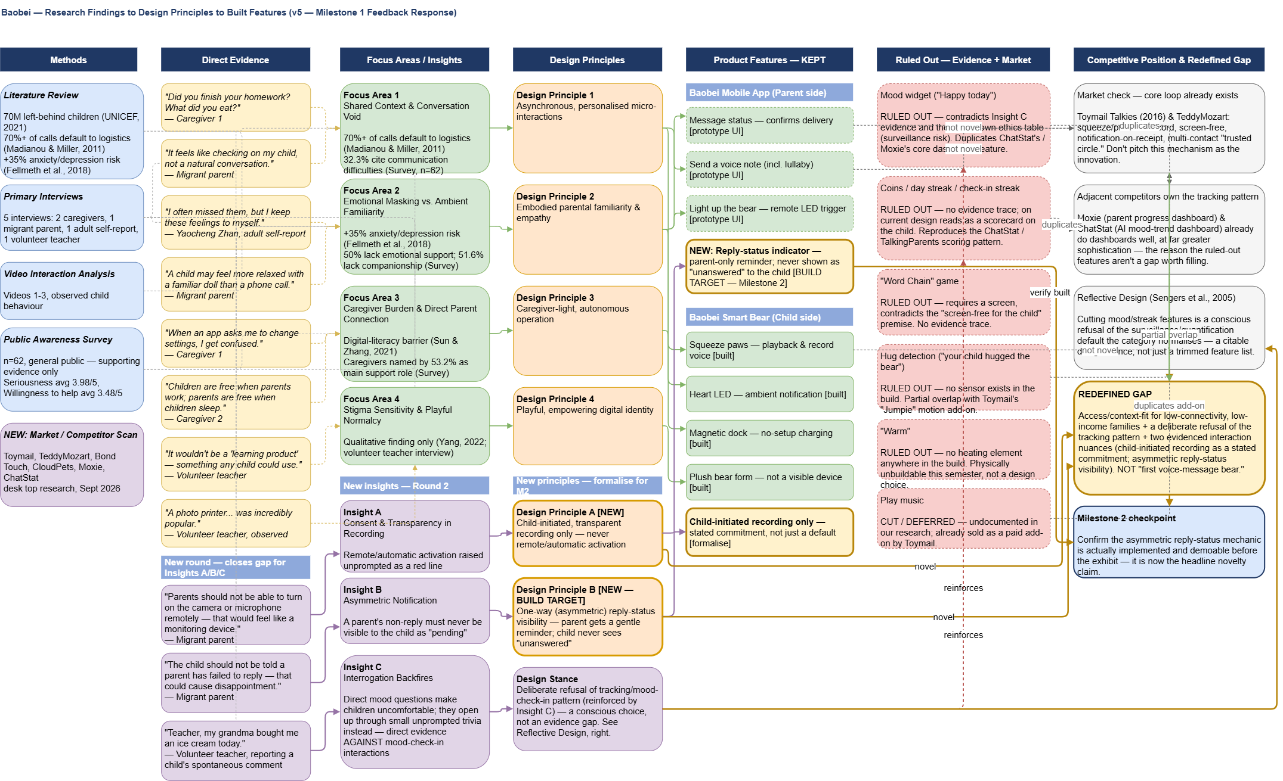
The v5 process map (research → insights → design principles → kept features → ruled-out features → competitive position → redefined gap) reflecting all of the above is shown below; the editable .drawio source is held separately for the team.

6. Redefined Gap
The gap is not "nobody has built a voice-message plush toy that lights up." That's Toymail Talkies, shipping since 2016. Claiming that mechanism as the contribution won't survive a market-literate assessor and shouldn't be the pitch.
The gap our own research actually supports sits at the intersection of three things none of the reviewed products cover together:
- Connectivity resilience, not price — Toymail and TeddyMozart assume a stable home Wi-Fi connection, and Moxie's collapse shows what happens when a companion device depends entirely on a company's cloud servers. Baobei's local-first architecture (on-device recording and playback, store-and-forward sync) is built for the intermittent rural connectivity our interviews actually describe — an engineering difference, not a marketing claim. (Cost is not yet a demonstrated advantage: our current BOM prices a single hobbyist prototype, not a manufactured retail unit, so we shouldn't lead with price until we have real unit-cost figures.)
- A deliberate refusal of the tracking/dashboard default — Moxie and ChatStat both treat a parent-facing progress or mood dashboard as their core value proposition; our own evidence (Insight C, the ethics table) says that pattern backfires for this population. Building without it is a stance, not an omission.
- Two specific, evidenced interaction nuances nothing else does — child-initiated-only recording as a stated ethical commitment, and asymmetric reply-status visibility so a parent's silence is never visible to the child as rejection.
This is a narrower, more defensible claim than "first companion bear for left-behind children" — but it's one the research actually earns, and it directly answers Chris's point 3: redefine the gap rather than keep pitching a feature list that a market scan takes apart in minutes.

7. Simplified Scope for Milestone 2
What survives, and why it's now a shorter list than the app's current Figma screens show:
- Send voice note / squeeze-to-record & play — the proven core loop (not claimed as novel)
- Ambient heart-light notification — the proven core loop (not claimed as novel)
- Message status on the parent app
- Asymmetric reply-status visibility — build this; it's the headline novelty claim and currently only exists as a design principle on paper
- Child-initiated-only recording, stated as a formal commitment (already true of the build; needs to be said explicitly, not just implied)
- Caregiver-zero-setup dock — kept, described honestly as good practice rather than a unique differentiator
- Local-first, offline-tolerant sync — now a headline part of the redefined gap, not just a background engineering task
Everything else audited in Section 5.1 (play music, coins/streak, Word Chain, mood widget, hug detection, "Warm") is cut, not deferred — each one either has no evidentiary basis, contradicts the ethics table, is physically unbuildable this semester, or is already a better-resourced competitor's headline feature.

8. Updated Roadmap / Next Steps
- Task: build and demo the asymmetric reply-status mechanic for Milestone 2 — currently a documented principle with no working implementation, and it's now the strongest single claim to novelty the team has. Needs a named owner and a feasibility check against the remaining timeline before Wednesday, given the team's known capacity constraints — if it can't be built in time, the pitch needs a fallback headline claim (local-first connectivity resilience is the strongest candidate).
- Add Sengers et al. (2005), "Reflective Design," and the ChatStat/Moxie comparisons to the report's related-work section as the critical-technical-practice framing for why the mood/streak features were cut.

